Grade Management System

Complete Project Documentation

1. Project Overview

1.1 Introduction
The Grade Management System is a Java-based console application developed to manage student academic records efficiently. The system allows users to add student data, calculate averages, assign grades, generate reports, perform analytics, and store data using file persistence.

1.2 Project Goals
- Manage student marks using structured programming and OOP.
- Automate average and grade calculation.
- Provide performance reports and analytics.
- Ensure safe input validation.
- Enable file-based data storage (persistent system).

1.3 Objectives
- Build a menu-driven academic system.
- Implement reusable class-based architecture.
- Apply file handling and exception handling.
- Demonstrate algorithmic and logical problem-solving.

2. Setup Instructions

2.1 Software Requirements
- Java JDK 8 or above
- IntelliJ IDEA / Eclipse IDE
- Operating System: Windows / macOS / Linux

2.2 Hardware Requirements
- 4 GB RAM minimum
- 1 GHz processor
- Keyboard and display

2.3 Installation Steps

Step 1: Install Java
- Download Java JDK.
- Install and set environment variables.
- Verify installation:
- java -version

Step 2: Install IDE
Install IntelliJ IDEA or Eclipse.

Step 3: Create Project
- Create new Java project.
- Create following packages:
- GradeManage_main
- GradeManage_StudentGrade
- GradeManage_GradeCal
- GradeManage_ReportGenerator

Step 4: Add Code Files
Add:
- Main.java
- StudentGrade.java
- GradeCalculator.java
- ReportGenerator.java

Step 5: Run Application
Run Main.java file.

3. Code Structure

3.1 Project Hierarchy
GradeManagementSystem
│
├── GradeManage_main
│ └── Main.java
│
├── GradeManage_StudentGrade
│ └── StudentGrade.java
│
├── GradeManage_GradeCal
│ └── GradeCalculator.java
│
└── GradeManage_ReportGenerator
└── ReportGenerator.java

3.2 Class Responsibilities

Main.java
- Menu system
- User interaction
- System control flow

StudentGrade.java
- Student data model
- Marks storage
- Average calculation

GradeCalculator.java
- Grade logic
- Input validation
- Constraints handling

ReportGenerator.java
- Report generation
- File save/load
- Analytics
- Top performer logic

4. Visual Documentation
Include screenshots of:
- Program start screen :-
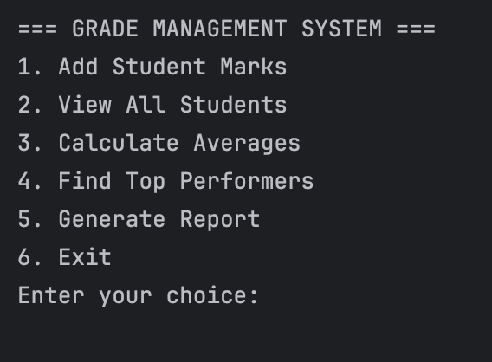
- Adding student marks :-
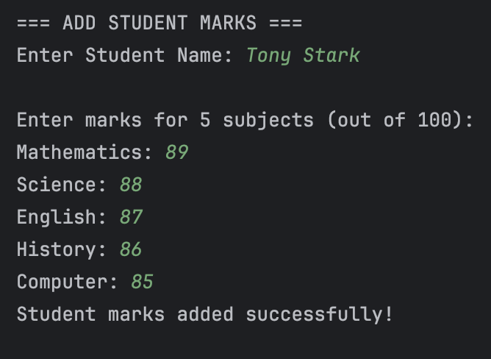
- Viewing all students :-
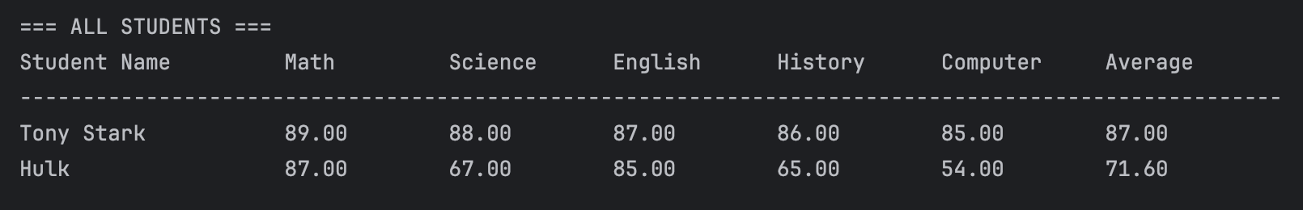
- Average and grade output :-
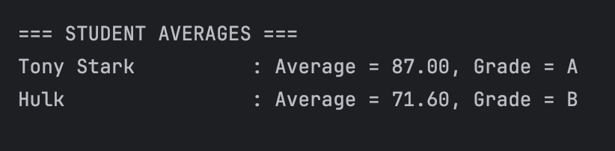

- Top performer output :-
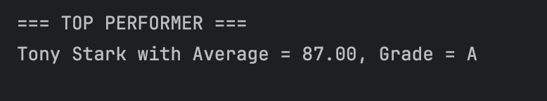

- Class report :-
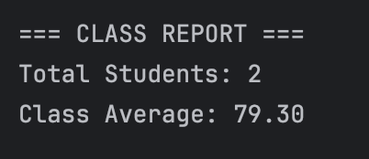

- File saved message :-
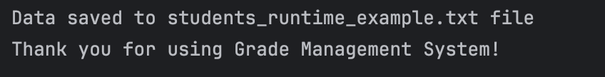

5. Technical Details

5.1 Algorithms Used

Average Calculation
average = sum of marks / total subjects

Grade Assignment
if avg >= 90 → A+
else if avg >= 80 → A
else if avg >= 70 → B

Top Performer
- Traverse all students
- Compare averages
- Store highest

File Persistence
- FileWriter → write data
- BufferedReader → read data

5.2 Data Structures Used
Structure | Usage
Array | Store students
2D data handling | Marks per subject
Objects | Student representation
Strings | File storage format

5.3 Architecture
System follows layered structure:
User Interface (Main)
↓
Business Logic (Calculator + Report)
↓
Data Layer (Student objects + File storage)

6. User Manual

6.1 Start Program
Run Main.java

6.2 Menu Options

1. Add Student Marks
- Enter student name
- Enter marks for five subjects

2. View All Students
Displays:
- Student name
- Marks
- Average

3. Calculate Averages
Shows:
- Student average
- Assigned grade

4. Find Top Performers
Displays highest scoring student.

5. Generate Report
Shows:
- Class average
- Total students
- Top performer

6. Exit
- Saves data to file
- Closes program

7. Grading System Explanation
Average | Grade
90–100 | A+
80–89 | A
70–79 | B
60–69 | C
50–59 | D
Below 50 | F
Grades are assigned automatically using conditional logic.

8. File Persistence
- Data saved in: students.txt
- Format:
Name,Math,Science,English,History,Computer
- Auto load on startup.
- Auto save on exit.

9. Validation Rules
- Marks range: 0–100
- Menu input must be numeric
- Exceptions handled using try–catch
- Invalid entries prompt re-entry

10. Testing Evidence

10.1 Test Cases
Test Case | Input | Expected Output
Add student | Valid marks | Student saved
Invalid marks | 150 | Error message
Menu invalid | letter | Prompt retry
Restart system | saved data | Data loads

10.2 Validation Testing
- Negative marks rejected
- Non-numeric menu blocked
- File missing handled safely

11. Performance Analytics
System provides:
- Class average
- Top performer
- Pass percentage
- Highest & lowest performance

12. Advantages
- Easy interface
- Accurate calculations
- Persistent storage
- Modular code
- OOP design

13. Limitations
- Console-based UI
- Limited to 100 students
- No database integration

14. Future Enhancements
- GUI using Swing/JavaFX
- MySQL integration
- Web application version
- Graph-based analytics
- Teacher login system

15. Conclusion
The Grade Management System successfully demonstrates student record management, grade automation, reporting, validation, analytics, and file persistence. The project fulfills advanced-level academic requirements and reflects strong understanding of Java programming, OOP concepts, algorithms, and system design.

